|  |  |
| --- | --- |
| **DATE** | **10-05-2023** |
| **TEAM ID** | **NM2023TMID06863** |
| **CODE** | **PYTHON** |

**1**.**Data Augmentation**

Insufficient learning examples prevent you from training a model that can generalize to new data, which leads to overfitting. If you had unlimited data, your model would be exposed to all characteristics of the current data distribution, preventing overfitting. By increasing the samples with different random changes that produce realistic-looking images, ***data augmentation*** uses the existing training samples to generate more training data. Your model should never view the same image twice during training. This makes the model more generic and exposes the other features of the data.

This is possible with Keras by defining a variety of stochastic transforms to be applied to the images with the *ImageDataGenerator* function. Let’s begin with an illustration.

* *rotation:* This is a range with which the images are rotated randomly. Its capacity lies from (0-180) degrees.
* *width_shift and height_shift:* ranges (as a fraction of total width or height) within which to randomly translate pictures vertically or horizontally.
* *shear:* is for randomly applying shearing transformations.
* *zoom:*is for zooming the images randomly.
* *horizontal_flip:*is for randomly flipping half the images horizontally
* *fill_mode:* is the method used to fill in newly produced pixels that may arise following a rotation or width/height change.

**2.BUILT THE CNN MODEL**

####-----Let's display some randomly augmented training images-------####

from keras.preprocessing import image

fnames = [os.path.join(train_cats_dir, fname) for fname in os.listdir(train_cats_dir)]

img_path = fnames[3]

img = image.load_img(img_path, target_size=(150, 150))

x = image.img_to_array(img)

x = x.reshape((1,) + x.shape)

i = 0

for batch in datagen.flow(x, batch_size=1):

  plt.figure(i)

  imgplot = plt.imshow(image.array_to_img(batch[0]))

  i += 1

if i % 4 == 0:

break

plt.show()

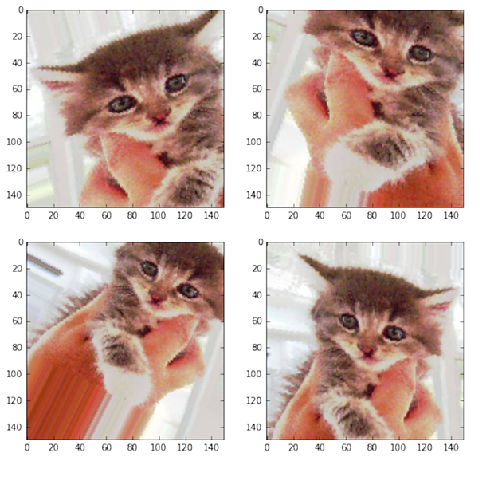

import numpy as np

import matplotlib.pyplot as plt

%matplotlib inline

from __future__ import print_function

import keras

from keras.models import Sequential

from keras.utils import to_categorical

from keras.layers import Dense, Conv2D, MaxPooling2D, Dropout, Flatten

**A.INPUT LAYER**

print('Training data shape : ', train_images.shape, train_labels.shape)

print('Testing data shape : ', test_images.shape, test_labels.shape)

# Find the unique numbers from the train labels

classes = np.unique(train_labels)

nClasses = len(classes)

print('Total number of outputs : ', nClasses)

print('Output classes : ', classes)

plt.figure(figsize=[4,2])

**B.Minimum 1 Convolution & 1 Pooling layer**

# Display the first image in training data

plt.subplot(121)

plt.imshow(train_images[0,:,:], cmap='gray')

plt.title("Ground Truth : {}".format(train_labels[0]))

**C.1 Flatten layer**

# Display the first image in testing data

plt.subplot(122)

plt.imshow(test_images[0,:,:], cmap='gray')

plt.title("Ground Truth : {}".format(test_labels[0]))

**OUTPUT LAYER**

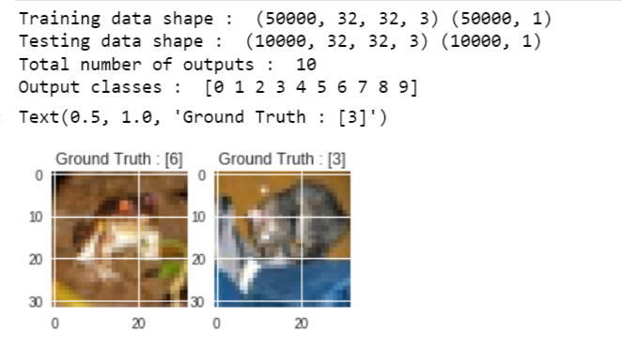

**D.Minimum of 2 Hidden layers**

|  |
| --- |
| train_data /= 255 |
|  | test_data /= 255 |
|  |  |
|  | train_labels_one_hot = to_categorical(train_labels) |
|  | test_labels_one_hot = to_categorical(test_labels) |
|  |  |

**print('Original label 0 : ', train_labels[0])**

**print('After conversion to categorical ( one-hot ) : ', train_labels_one_hot[0])**

**E.OUTPUT LAYER:**

Original label 0 : [6]  
After conversion to categorical ( one-hot ) :   
[0. 0. 0. 0. 0. 0. 1. 0. 0. 0.]

**3.TEST THE MODEL**

**import matplotlib.pyplot as** **plt**

**import matplotlib.image as** **mpimg**

**import seaborn as** **sns**

**import numpy as** **np**

**import pandas as** **pd**

**import** **re**

**import** **os**

**import** **glob**

**import** **cv2**

***TEST***

**from sklearn.model_selection import** **train_test_split**

**from sklearn.metrics import****\***

**import matplotlib.pyplot as** **plt**

**from sklearn.model_selection import****\***

**from sklearn.preprocessing import** **StandardScaler**

**from sklearn.model_selection import** **train_test_split**

**from sklearn.preprocessing import** **StandardScaler**

**from sklearn.feature_selection import** **VarianceThreshold**

**from sklearn.pipeline import** **make_pipeline**

**from sklearn.feature_extraction.text import** **TfidfVectorizer**

**from sklearn.decomposition import** **TruncatedSVD**

**from skimage import** **data, color**

**from skimage.transform import** **rescale, resize, downscale_local_mean**

**import matplotlib.image as** **mpimg**

**from sklearn.linear_model import****\***

**from sklearn.preprocessing import****\***

**from sklearn.ensemble import****\***

**from sklearn.neighbors import****\***

**from sklearn import** **svm**

**from sklearn.naive_bayes import****\***

**import xgboost as** **xgb**

***#deep learning libraries***

**import tensorflow as** **tf**

**from tensorflow.keras import** **Sequential**

**from tensorflow.keras.layers import** **Dense,Conv2D,MaxPool2D,Flatten,Dropout,BatchNormalization**

**from tensorflow.keras.optimizers import** **Adam**

**print(tf.__version__)**

***# for confusion matrix plotting***

**from mlxtend.plotting import** **plot_confusion_matrix**

**from sklearn.metrics import** **multilabel_confusion_matrix,confusion_matrix**

**2.3.1**

**In [5]:**

**os.listdir('/kaggle/input/african-wildlife/buffalo')[:7]**

**Out[5]:**

**['361.txt', '208.jpg', '029.jpg', '245.txt', '014.jpg', '141.txt', '372.txt']**

**In [6]:**

**data=open('/kaggle/input/african-wildlife/buffalo/184.txt')**

**data.read()**

OUTPUT :

**'0 0.482284 0.471683 0.821334 0.824703\n'**

**TESTING THE MODEL :**

**In [7]:**

**k=0**

**for** **i in os.listdir('/kaggle/input/african-wildlife/buffalo/'):**

**if** **i[-3:] !='txt':**

**img=mpimg.imread('/kaggle/input/african-wildlife/buffalo/'+i)**

**plt.imshow(img)**

**plt.show()**

**k+=1**

**if** **k==3:**

**break**

